Product Design Report

MSE 2202b - Introduction to Mechatronic Design

Group #5 Dilbot

April 8, 2015

Alexander Porrone - 250733678

Alexandra Matyas – 250731162

Ian Stothart - 250720354

**Table of Contents**

Executive Summary……………………………………………………….....................................1

Introduction………………………………………………………..................................................2

Decision Making and Design Tools……………………………………………………………….3

Results & Discussion…………………………………………………...........................................5

Initial Concepts…………………………………………………........................................5

Prototype…………………………………………………..................................................7

Final Product Design………………………………............................................................8

Code Development…………………………………….....................................................10

Conclusions………………………………………………………................................................14

Recommendations………………………………………………………......................................15

Appendix…………………………………………………………………………………………21

Appendix I – SOTA Report………………………….......................................................17

Appendix II – Quality function Deployment chart………………………….…….…….19

Appendix III – Pseudo Code…………………………………..……………….….……..20

Appendix IV – Decision Matrices……………………………………………....……….24

Appendix V – Design reviews…………………………………………………...………27

References……………………………………………………….................................................31

**Executive Summary**

The objective of this project was to engineer an autonomous mechatronic system to retrieve and deliver empty and full water bottles from tables of varying heights and locations. The steps taken to carry out the development of the system are outlined in this report. The initial design was constructed from a simple rectangular base with four wheels attached to a turntable mounted with vertical and horizontal rail systems. Grasping of the water bottle was achieved using a standard vex claw kit, though the final product was designed using a gripper from makeblock. The initial prototype developed from the design had a number of structural issues which were dealt with and then used as an indicator of issues that may have arisen with the final product. Coding was carried out during and after the construction of the prototype, with the initial movement code tested on an incomplete chassis. Sequential code was added in after the completion of the mechanical build of the robot. Moving forward, the design could be improved by the use of higher quality sensory hardware and further coding that addresses the issue of obstacle navigation. There are several discrepancies between the finished product and the prototype which attempt to address the mechanical issues experienced with the first robot. The final product is a robot which is as simple as possible given the requirements of the project.

**Introduction**

The task given for the project was to develop a delivery system for water bottles and newspapers on tables of varying configurations. Vex kits were provided to groups for the construction of the prototype, as well as training with solid works. LEDs that were blinking or solid identified the side of the door, recycle bin, or table that the robot was on. The robot had to be able to retrieve and deliver full and empty water bottles as well as newspapers between multiple rooms. The mechatronic device which was decided upon in the early stages was a mobile robot, since the size of the rooms could vary making a stationary system a poor choice. The design specification led to prioritization of certain aspects of the robot.

The group decided that the robot should have ample vertical and horizontal reach, a durable chassis, and efficiency to make the most of the robot’s battery.

Maintaining simplicity in both the finished product and the prototype were important to ensuring the success of the project. Simplicity was achieved through avoiding the overuse of fasteners and gears. Lighter material was used on the upper portion of the robot to avoid inducing moments which would cause deformations. Initial designs used a rotation mechanism that was elevated which created problems with weight. The final design had a rotation mechanism at the bottom of the robot to reduce this weight problem. Support was added to different locations of the robot until a final, rigid prototype was developed for testing.

Coding the robot had several challenges. Research was done on navigation and the simplest option was chosen due to the time constraints of the projects, as well as the scope of the project. Mapping was deemed unnecessary as the complexity was very high for an arduino, in addition an algorithm was developed for room navigation.

**Decision Making & Design Tools**

Decisions were made weighing all design specifications and constraints. Decision matrices and general discussion were used to assist with decision making. Solidworks was used to assist with the design of the prototype and the final product. In addition a Quality Function Deployment chart was conceived to help determine the engineering characteristics that would weigh in with the most importance during our design process.

We identified our customers as individuals in a traditional household setting who wanted to recycle water bottles and newspapers that they left on the coffee table or counter. This designation of customers was used as the basis for generating the specifications put into the decision matrix shown in appendix IV along with our Quality Function Deployment chart in appendix II.

The weighted results for the decision matrix were used in the three categories of components, as well as navigation algorithms in order to select the best one for the consumer.

Some consideration was given to the fact that the robot was being programmed with the arduino language and on a board which may have made it difficult for very complex computing tasks and limited storage.

During the selection of our parts, the results from a Quality Function Deployment chart determined special characteristics that our build robot should possess in order to properly capture the attention of our target market. It was determined that above all we needed a design that was simple to code for with the fewest moving parts along with having many viable grabbing options. It is with these characteristics in mind that we took all of our brainstormed concepts under consideration selecting concepts that would best suit our target market.

Solidworks was used for the mechanical design of the prototype. The reason for this was to check to see how components would fit while the group was outside of the lab and to see the range of motion afforded by different designs. The final prototype required more reinforcement once actually constructed due to the moments induced by the extension of the horizontal rail. Please refer to our Product Development file for images of both our prototype and final design. Rails.

In addition to solidworks, the design reviews were used to monitor the progress of the development of the prototype as well as to receive input from the course instructor. Copies of the design reviews can be seen in appendix V.

The final design gave more consideration to the safety of the consumer. To increase safety, most moving parts were covered. It is also planned for our robot to use encoder counts to determine if there is ample force resisting movement on any of our running motors and to shut down the robot if this becomes the case. This is in the interest of avoiding prolonged collisions with others as the robot completes its sequence.

**Discussion**

**Initial Concepts**

The initial concepts to be developed where movement, arm or claw gripping mechanisms, height adjustment and sensing options. The initial movement options consisted of using three wheels with a pivoting wheel in the front similar to that of what was seen in the labs or using four wheels with two wheels on either side always moving at the same speed. Another option for the wheels was the use of two Omni wheels along with two standard wheels. In the end the use of four standard wheels was chosen for its simplicity. Initially a fixed pinion and rack gear system was developed which would move the entire rail. Upon revision, it was decided that moving an entire rail would be a lot of weight for the motor. To account for the extra weight the rack became fixed with a moving pinion creating an elevator putting less strain on the motor. A standard vex claw kit was attached to the end of the horizontal rail system to grab the water bottle. The height difference, measured to be 37cm required an elevation option which provided enough clearance over both tables. The options discussed included a scissor idea, a bendable elbow and finally a multiple rail extension to achieve greater heights. The final design for the elevation system was a rack and pinion with custom rails machined to a length of 24 inches. In terms of sensors, it was decided to use standard sensors given to us in our vex kits, using photo resistors to detect lights and ultrasonic range finders to detect distance. Through the competition on our prototype it was determined that these methods remained effective for our final design, though an infrared light and sensor may be used in our final product as an additional distance sensing method.

Sensing options

The mechanical design called for 6 motors on the master board, leaving very few pins left for sensors. In the interest in utilizing the remaining pins as effectively as possible, only two ultrasonic sensors used the remaining digital pins, accompanied by two light sensors on the analog pins. The ultrasonic sensors in particular were troublesome as they took up 2 pins each. The use of a button was implemented on a slave board that was able to communicate with the master board notifying the master board of collisions with the front of the robot.

Height

Scissor lifts were investigated as a possible elevation method, however after watching videos of their operation and schematics of their construction they were found to be complicated and subject to internal forces that were difficult to deal with. Standard vex rails were unable to provide satisfactory clearance for either table. In order to provide the extra clearance, custom rails were manufactured in the student machine shop using a drill press and sheet metal. The curve profile of the standard vex profile was created using a manual break. Circular holes were made instead of square holes to save time.

Grasping

Although several grasper concepts were discussed, it was decided that the standard vex claw kit would work with the water bottle. For the final product, other claws were investigated resulting in the choice of the claw kit from makeblock. Make Block's sturdy metal construction, and the 12 volt DC motor, which was included with it aided in this decision. Instead of a universal gripper, a separate system was used in order to retrieve water bottles. After the grasping system was developed the methodology for movement was developed.

Movement

The course was designed with tiles, which allowed for wheels to slip. To take advantage of this, a gear train similar to a bobcat was developed. The weight of the door would make it difficult to have a design which had all wheels as an Omni wheel configuration because the door would push the robot against the wall, trapping it. In the final design, Omni wheels would be used on the front of the chassis to allow for turning on high friction surfaces like a carpet.

**Prototype**

The final design has many features which remain the same from our prototype that lead to the accomplishment of our goals. These concepts include the water bottle grabber design and the newspaper grabber design. Other features include stability and the turntable.

It was decided that for the gripping mechanism the standard vex claw would suffice. The claw used in the labs provided an easy solution to the design of the water bottle grabber as there was no need to change a design that has already proven to work.

The Newspaper retrieval system was initially a bucket design that would hold the newspaper after the claw dragged the newspaper off the table. However, this idea was not used because the bucket would not be easy to empty after being filled. This failed concept let to the creation of our next concept which included multiple rubber gears attached on one rod. The gears would be controlled by one motor. When the motor turned, the gears would be able to grab onto the newspaper and suck in the paper into a holder similar to how one's bills are collected from a vending machine. The newspaper holder needed a “scoop” or guide attached from the bottom of the rectangle frame in properly hold the paper.

Another common issue faced with the prototype design was stability. Throughout the iteration process, numerous changes were made to the structure of the robot in order to further improve the stability of the robot and each component. Basic revisions included a cross beam support added to interior of the base which allowed additional support, a place to rest the battery and some extra stability for the chassis and neck mount.

An additional beam was added to each side of the wheelbase for stability of the wheel axle and to provide a wider base to counter-weight the moments of the neck and arm. Multiple support mechanisms needed to further be added to the neck of the robot to allow for greater rigidity for the turntable to be mounted above.

A turntable was placed at the top of the chassis mount and acted as the base and pivoting point for the neck. As a pivoting point, the turntable allowed full rotation of the neck and provided increased range of motion for the grabbing of the water bottle when the robot was able to sweep across the table via turntable.

**Final Product Design**

The mechanical design for the final product is very close to the prototype, however some considerations are given to increase reliability and safety. Sharp edges are eliminated by using circular rails for the elevation of the grasper. A plastic mould is then made to cover the chassis and cover the gear train to prevent the consumer from the pinch points along the gear train. The mould has draft angles built in for easy manufacturing.

The final product has less fasteners than the prototype in order to reduce the number of components and speed up the final production process. The gear system used was identical to the prototype’s gear system. Though alignment would be produced to a higher degree of tolerance to avoid buckling of gears during use.

The rack gears used for linear actuation of the arm dolly were custom made with a pressure angle of twenty degrees and a module of 3.5 in order to avoid using several smaller gears. Although it is more complex to manufacture the gears instead of ordering them from a supplier, the custom gears reduce the number of parts required, fasteners and gear sections, considerably. Another deviation from the prototype were the motors used.

Twelve volt motors were used in the final design in order to be able to access a wider array of batteries to use as power sources. One of the power sources considered was a car battery, however the acid within the battery would be dangerous. A lithium polymer battery was decided to be used as the main battery for its advantages over nickel metal hydride and lead acid batteries. Lithium polymer batteries can be charged whenever the user has time, unlike NiMH batteries which must be recharged only when the battery is fully drained. There is no risk of spillage of acid with lithium polymer batteries. The robot also had the wheel configuration modified to use less battery power in turning.

The final product uses two Omni directional wheels on the front of the chassis in order to improve turning by reducing the amount of slipping need by the robot in order to turn. The Omni wheels will allow for less exertion during turning while still maintaining friction while travelling through the door. Although vex components were re-used for the wheel base in the final design, the gripper used was replaced by a gripper from makeblock.

The gripper from makeblock is advantageous in that it uses less gears, which are subject to wear and create pinch points, which was identified as a potential hazard during the development of the prototype. In addition, the makeblock gripper comes with a 12 volt motor which is compatible with the voltage of the other motors used for linear actuation, motion and rotation on the final design. Another consideration which was given to manufacturing was the drill bit sizes used.

Drill sizes of #29 for 8-32 screws and #18 for the vex shafts were used for all screw holes on the chassis. The reason the #29 drill was used was because it fits the same 8-32 screw specification given by Vex. The #18 drill holes were found on solidworks to be the smallest size which fit the shafts. Using standard drill and bolt sizes will facilitate manufacturing because there is no requirement for custom hardware. Some modifications were made to the specifications of the prototype rails.

The vertical reach of the robot was extended considerably in the final design in order to account for even higher tables such as bars, the robot is able to reach tables just below three feet tall. In addition to these mechanical changes, several changes would be made to the code structure of the final design in order to increase the functionality of the device.

The time frame for the development of the prototype made it difficult to achieve all the goals the group initially set out to do, specifically the collection and delivery of newspapers. The methodology for retrieving and delivering newspapers is described below in the code development section, as well as how it would be integrated into the existing framework of code.

**Code Development**

Coding development began during the process of our physical development to test many of the concept iterations produced throughout the overall development. We started our development with the production of coding diagrams within vision to produce a logic map of how our code should work. Base code was then produced to lay groundwork for the code to come, this included initializing all pins on both boards and declaring variables for all pins along with the declaration of many constants and Booleans that would be later used in the code.

We had decided that the best way to structure our entire code was within one large switch statement where it would be easy to jump between multiple case statements wherever needed. With this is mind our code was initialized in case zero where the turret on the top of the robot had its encoder calibrated to a constant zero position by rotating until it hit a mechanical stop. The robot then proceeds into the following case of code where it makes a three hundred and sixty degree turn and notes the position on the wall that is closest to itself. The robot then continues to spin until reaching the encoder position which had the shortest ultrasonic distance recorded. The distance the robot is positioned away from the wall is then recorded and based on a target distance of 9 inches the robot moves either farther or closer to the wall and aligns itself again parallel to the wall with the ultrasonic range finder facing the wall.

The robot then advances and maintains a targeted distance from the wall as it follows the perimeter of the room. Wall distance is maintained by determining whether or not the robot is moving towards or away from the target distance. With this data in mind a decision is then made based off whether the robot is currently under or above the desired distance from the wall. While the robot is following the parameter of the room it is constantly scanning its light sensors. Based on the number of readings it receives it is able to determine whether or not at the end of each wall it needs to reverse itself back to an object seen or continue following the next wall in the parameter of the room.

Through the completion of the previous sequence it is expected that the robot will eventually see the door in which case it will reverse itself into the middle of the door and made a 90 degree turn along with aligning its turret so that it may fit through the door. The robot then proceeds into the middle of the adjacent room where the same code as referenced previously is run through to find the wall of the room and travel around the perimeter. As this is being completed the robot will then stop when it arrives in the front of any light on the low table. It is here where the robot will repetitively scan the length of the table until it sees the water bottle sitting on top of the table where it will stop in front of it and proceed to extend its horizontal rail until it is in front of it where it will grab the bottle and retract its horizontal rail.

This is the point in which our news-paper code would be implemented, though we did not have time to code it. If implemented the logic would be as follows: the water bottle would be placed at the edge of the table where the robot would then scan through entire lengths of the table for the newspaper with a line tracker. The robot would then attempt to align itself in the middle of the newspaper, turn on our intake motors drop our drag motor and pull the paper into the intake. The robot would then re-grab the water bottle hence completing the conceptual code for our robot.

The regular routine is resumed with the robot following the perimeter of the room until the door is found where is will repeat the same procedures as previously mentioned in going through the door and realigning itself in the next room to follow the perimeter of the room until the recycling bin is found. It is here that the robot will take readings over the period of a second of its light sensor to determine if the light is seen was blinking or solid. Based on this information the robot makes the decision to move forwards or reverse to align the horizontal rail in the middle of the recycling bin where it will then drop the water bottle into the bin.

The robot will now raise its vertical rail to the top of the high table and preform the same sequence of events as previously mentioned for picking up the water bottle and newspaper from the low table. When this is completed the vertical rail will remain raised and the robot will follow the perimeter of the room until the next corner the robot runs into in which the vertical rail will be lowered to avoid issues in the rail hitting the table. The robot will then repeat all code needed to get to the short table for a second time where it will align itself in the middle of the table and dispense both the newspaper and water bottle on the middle of the table.

For a visual representation of the previously mentioned code, please refer to appendix III.

**Conclusions**

The final design of the robot was designed to be as efficient and effective as possible as required to be to meet the requirements previously stated in the beginning of the project, while remaining in the given constraints. The robot was able to complete all tasks required within partial segments of code proficiently and repeatedly. Due to constraints of being unable to have an open testing room available to us the idea of testing our entire sequence in one run became unfeasible, though we were able to successfully complete all tasks in separate portions. The performance and success of the prototype was largely due to the simplicity in which code was written with. All primary complex algorithms were written in functions that could be easily executed at any time. This combined with limiting the number of moving components needed in the physical design of the robot provided the framework needed for proficient execution of goals. With the following kept in mind a product was able to be produced that met the design principles set out for the project with minimal compromise. This was all achieved within the tight framework of constraints given.

**Recommendations**

Through careful consideration and planning a product was created that fulfilled all design requirements set forth. However, as with any product there is always room for improvement. The abilities of the proposed design could be easily expanded with the allocation of a more generous timeline along with the changing of some hardware based on issues we learned from within the prototype.

Further development of this project should first be led into the direction of creating an additional iteration of a prototype. Through the testing some clear design flaws were discovered within the movement system. It was seen that turning was heavily based off of encoder counts and the encoder counts needed to make a perfect ninety degree turn would change depending on floor surface, due to the nature of the movement system. In an effort to combat this, in future iterations it would be recommended that the two front wheels be replace with Omni wheels of the same size. This would alleviate the turning from being based on sliding and make the robot significantly easier to code.

A further recommendation for a second prototype would be the replacement of current movement motors for larger ones, or the addition of a motor for each side of the robot. It was found that if the current motors were held at a constant position briefly while powered they would not continue moving when pressure was released until they were powered down. The iteration suggested for the next prototype would eliminate this issue and yield more consistent results with our robot.

In addition to the hardware changes suggested further investigation could be implemented into coding to yield more robust results. This could be achieved simply through the input of more man hours into coding that we were constrained by in our current prototype. It could be planned in the future, with proper resources to implement obstacle navigation. This could be achieved through the use of image recognition software/code, though for this to be seriously pursued we would need a great increase in both our budget and time constraints.

**Appendix**

**Appendix I: SOTA Report**

***Introduction***

Problem Definition

Design a mechatronic device to assist with the delivery and recycling of water bottles and newspapers within a home.

Scope of the SOTA Report

Autonomous delivery systems.

Discussion

This report will outline all technologies researched which perform autonomous delivery, discussing the disadvantages and advantages of each of these technologies as well as their functionality. In addition, technologies which are in development will be discussed and how they could be of future benefit to the device developed throughout the development of Dilbot.

***Modern Technologies and Processes***

DHL Parcelcopter service in Germany

DHL launched a new quad rotor drone it called the Parcelcopter last year in Germany. The quad copter was able to navigate a 12km route on the island of Juist in Europe. The quad rotor delivers all kinds of parcels.

Room Mapping Robot - The Rossum Project

The Rossum project begins its positioning algorithm with a 180 degree sweep. After the 180 degree sweep, it computes what are known as feasible poses. These feasible poses are positions where the expected view of the robot approximately matches the observed range sensor data. These feasible poses are used to assist in constructed a map of the robot's surroundings which is then stored in EEPROM. With further revisions to the navigation code of Dilbot, an algorithm similar to this could be used.

***Future Technologies and Processes***

USC - Defining Socially Assistive Robotics

Researchers at USC looked into different tasks that could be performed by robots in order to assist society in general. Tasks looked into included tutoring, physical therapy, daily life assistance, and emotional expression. Dilbot falls under the category of daily life assistance and could perhaps assist groups of individuals like the elderly or individuals with cognitive diseases. If the gripper module were modified to include rotation, it is possible that Dilbot could eventually be reprogrammed to do even more than the initial task of retrieving water bottles and newspapers in the future.

**Appendix II: Quality Function Deployment**

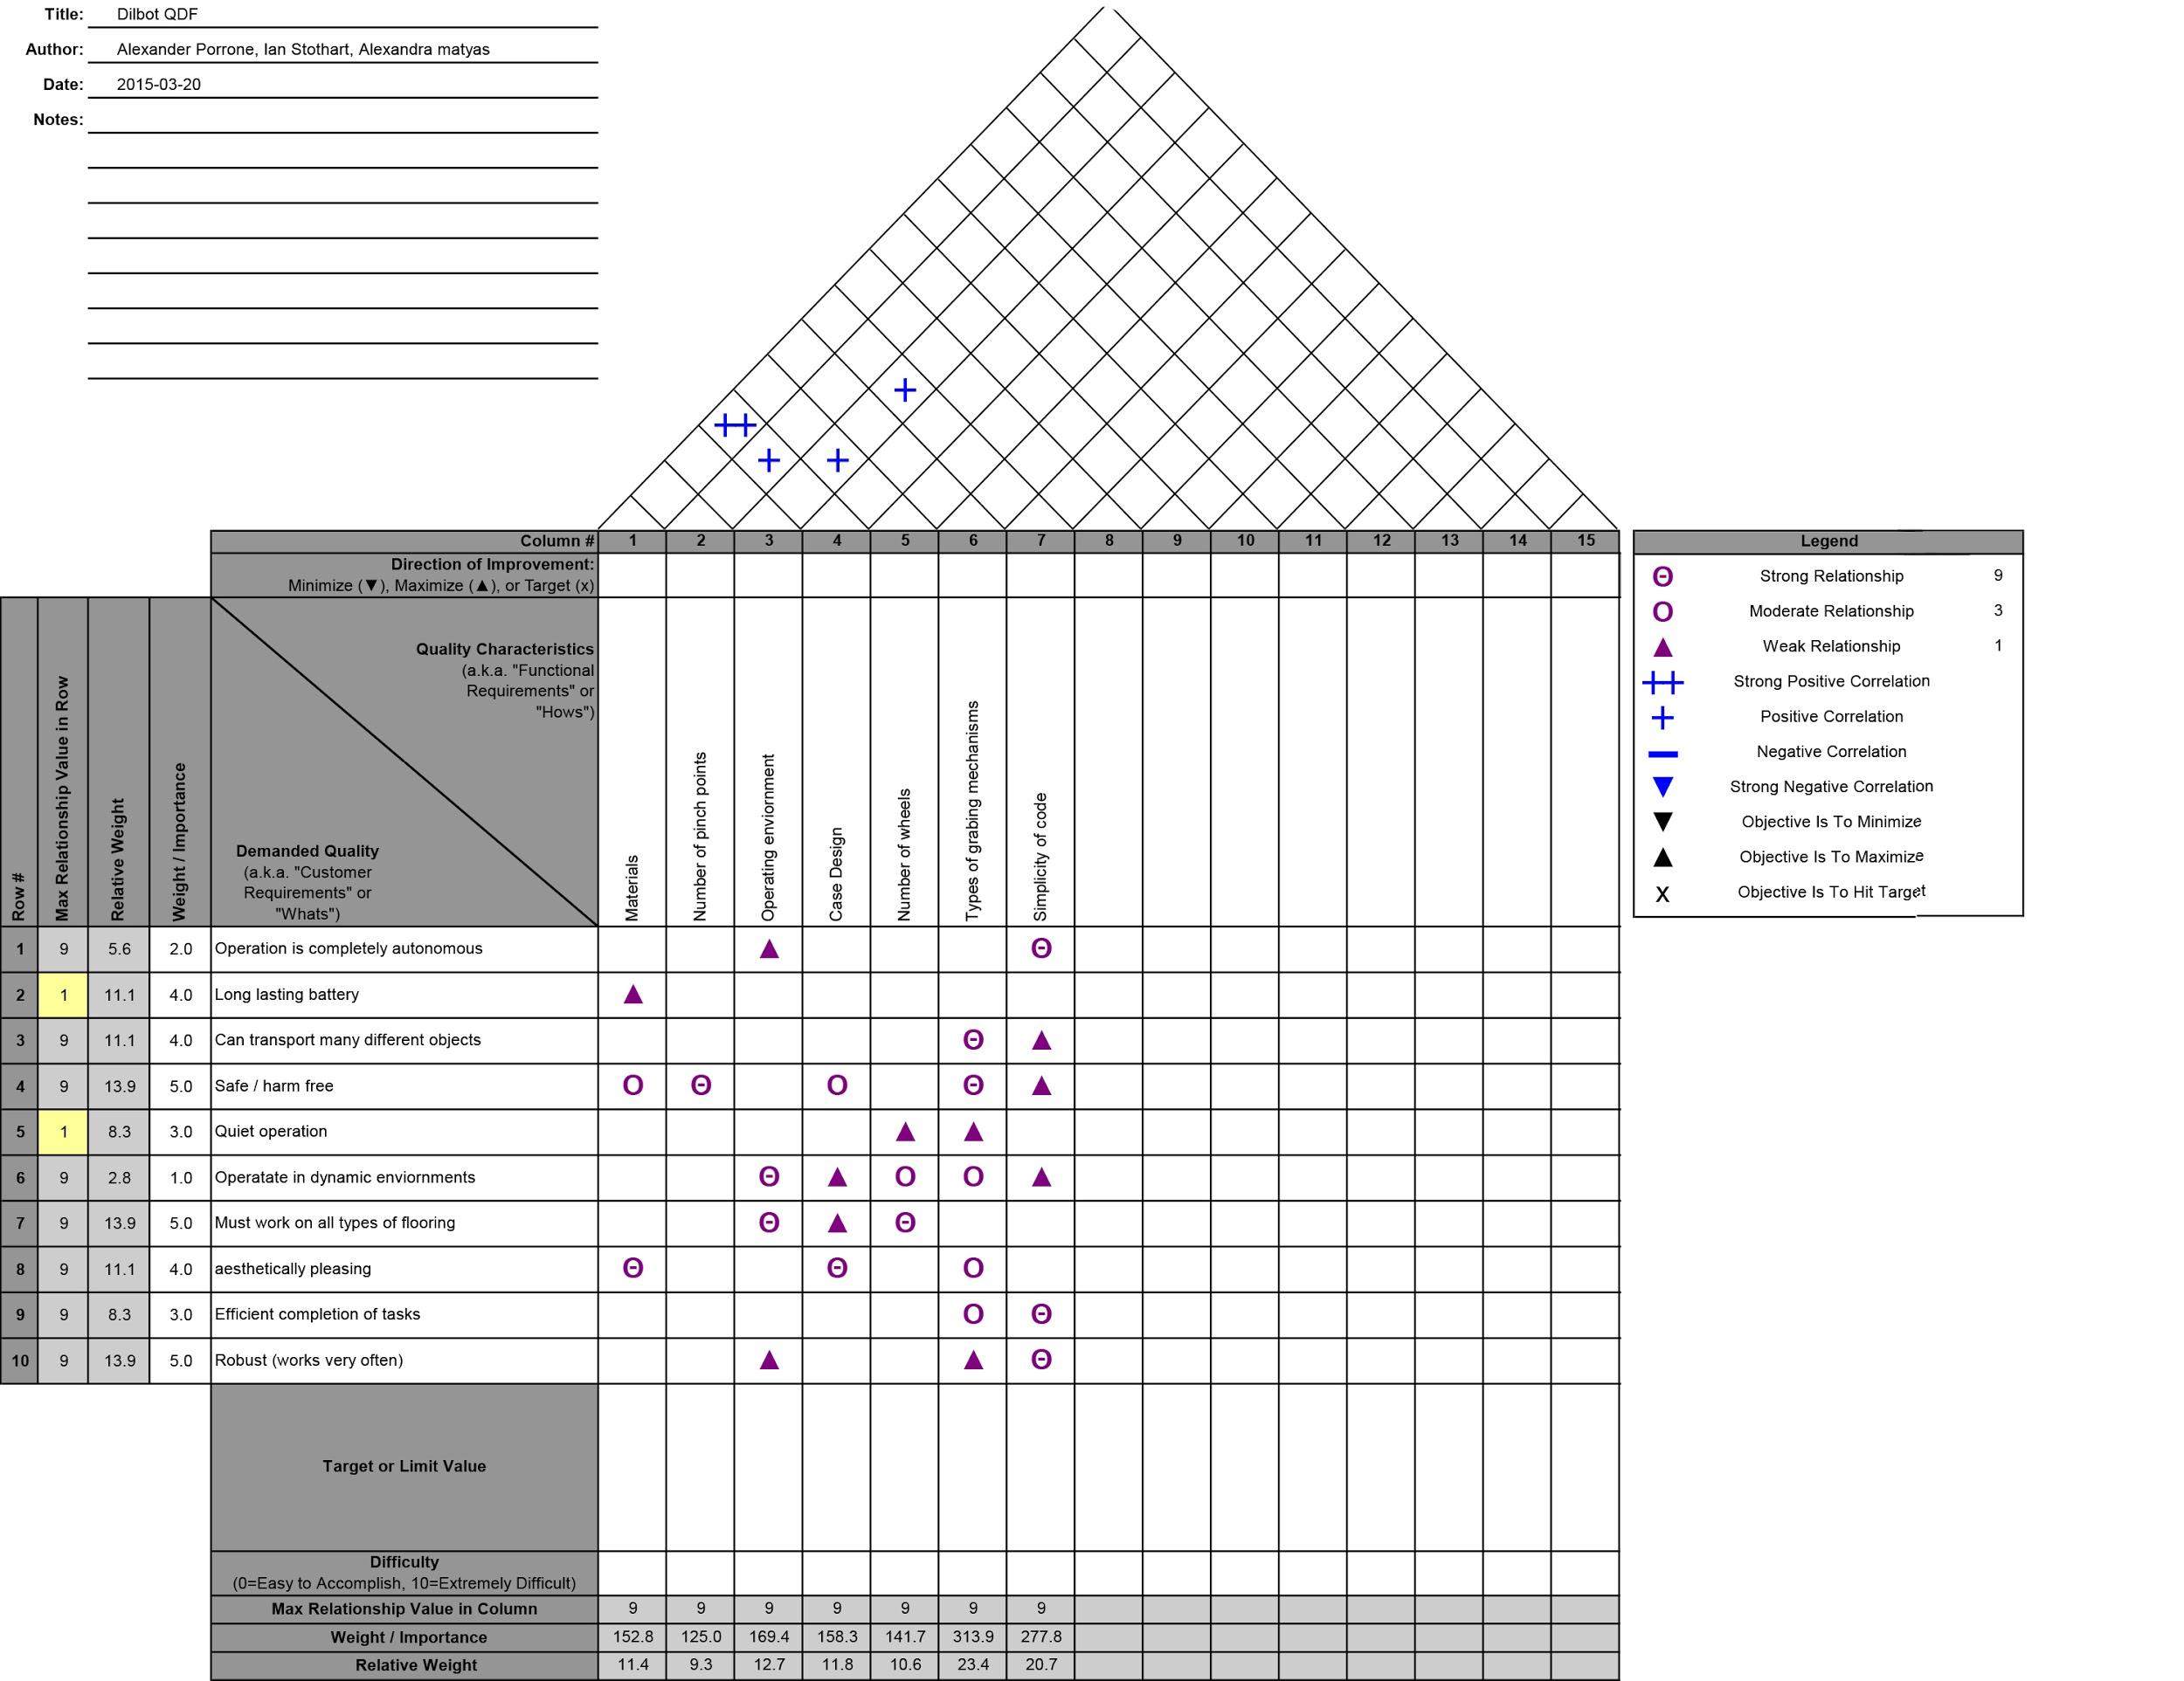

**Appendix III: Pseudo Code**

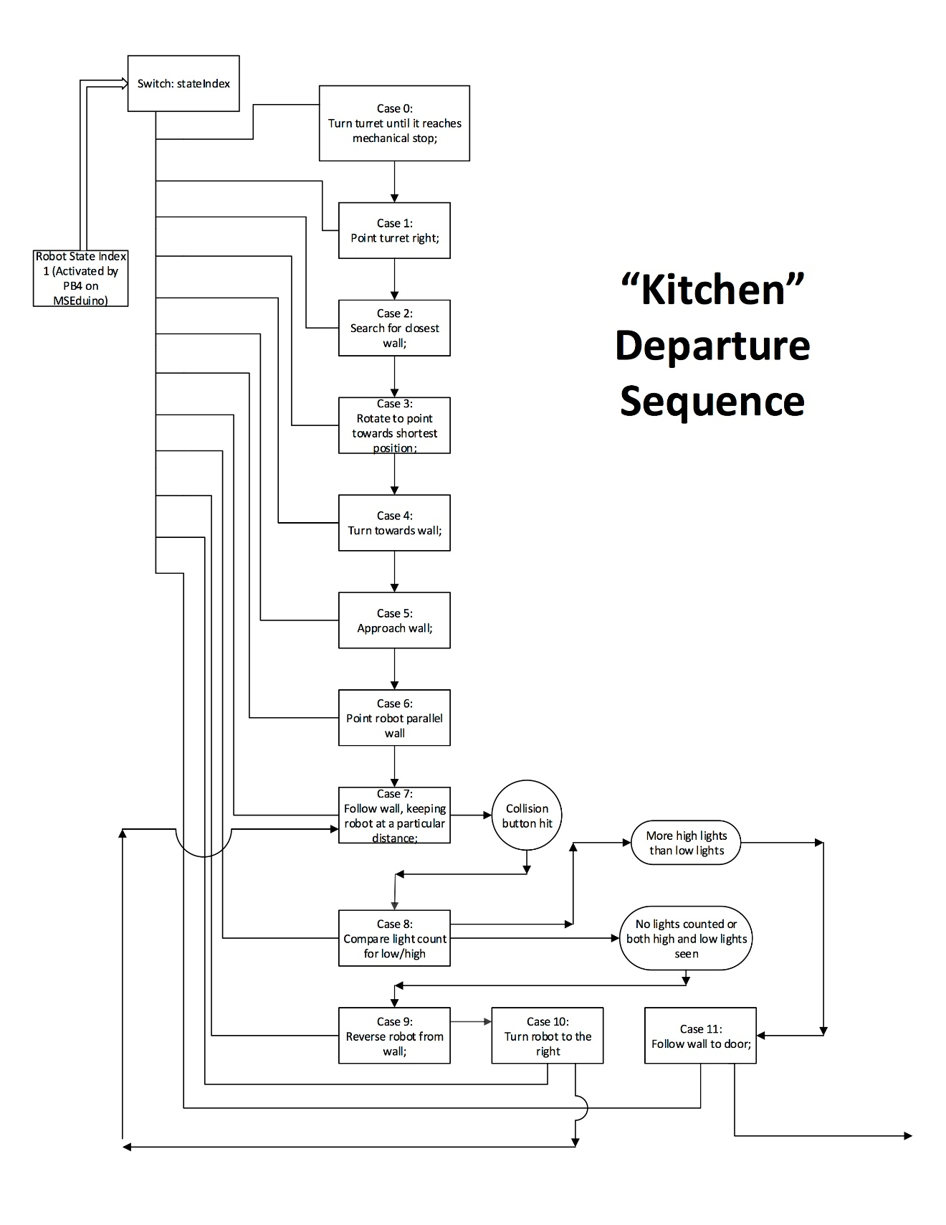

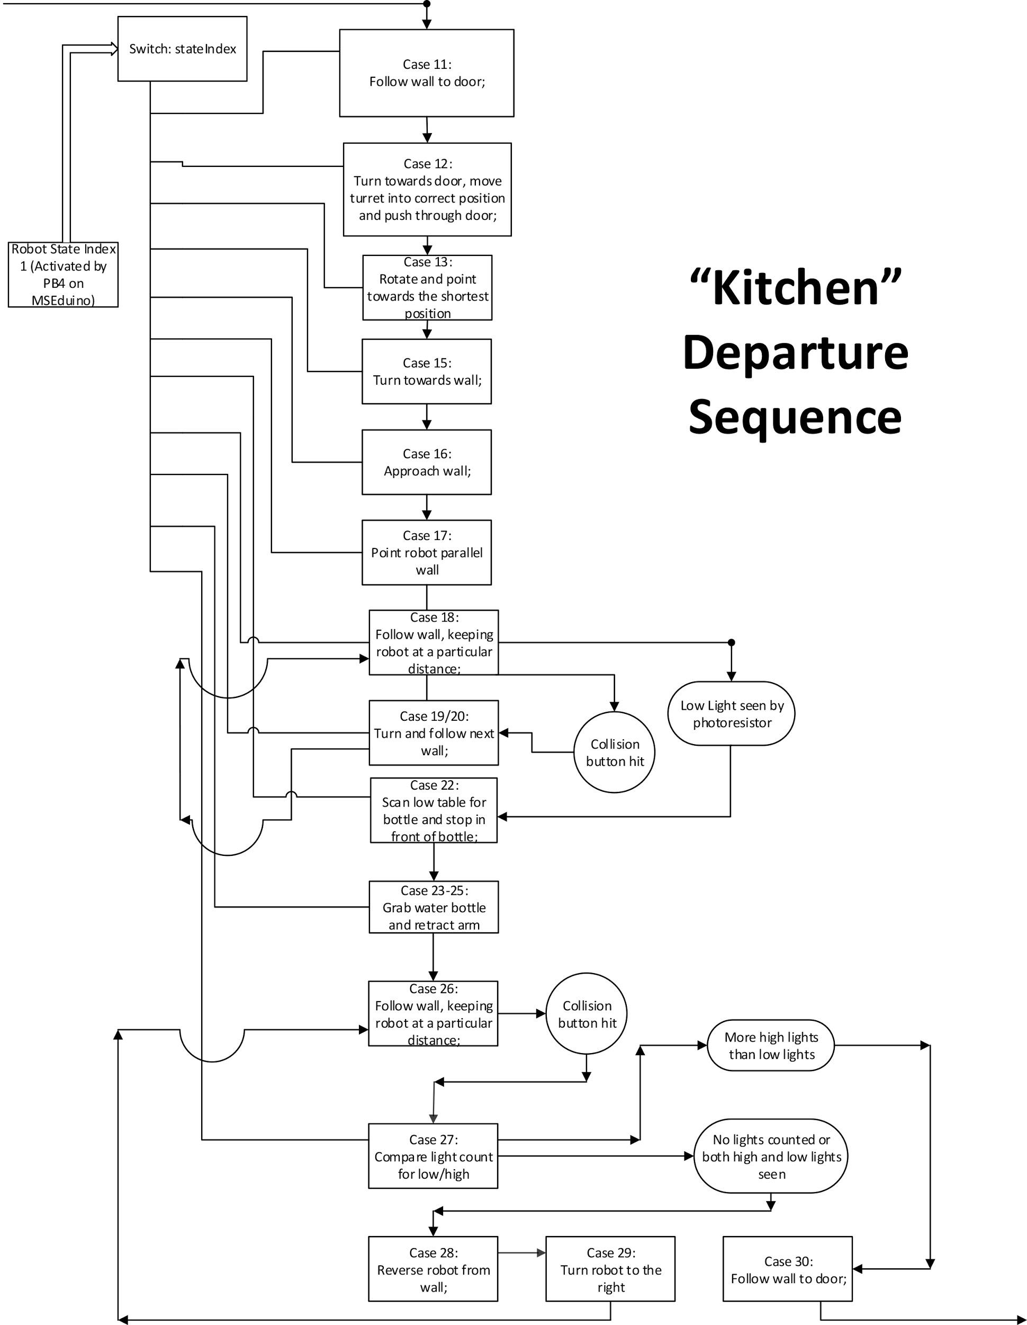

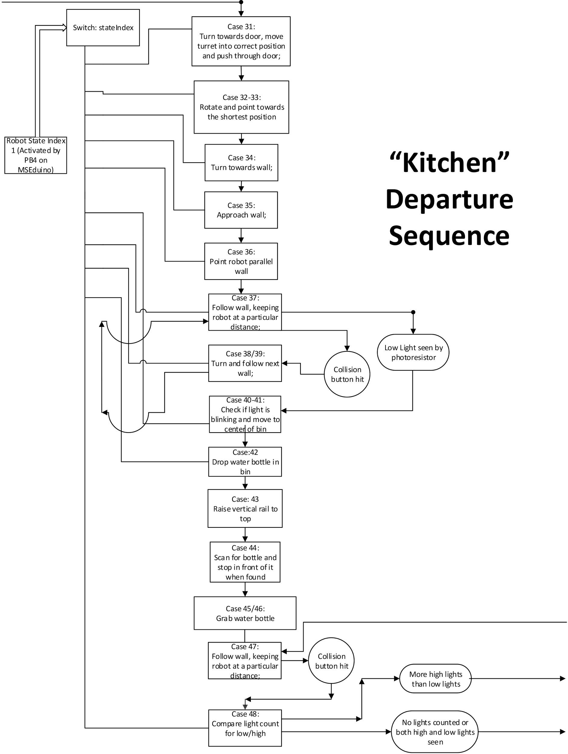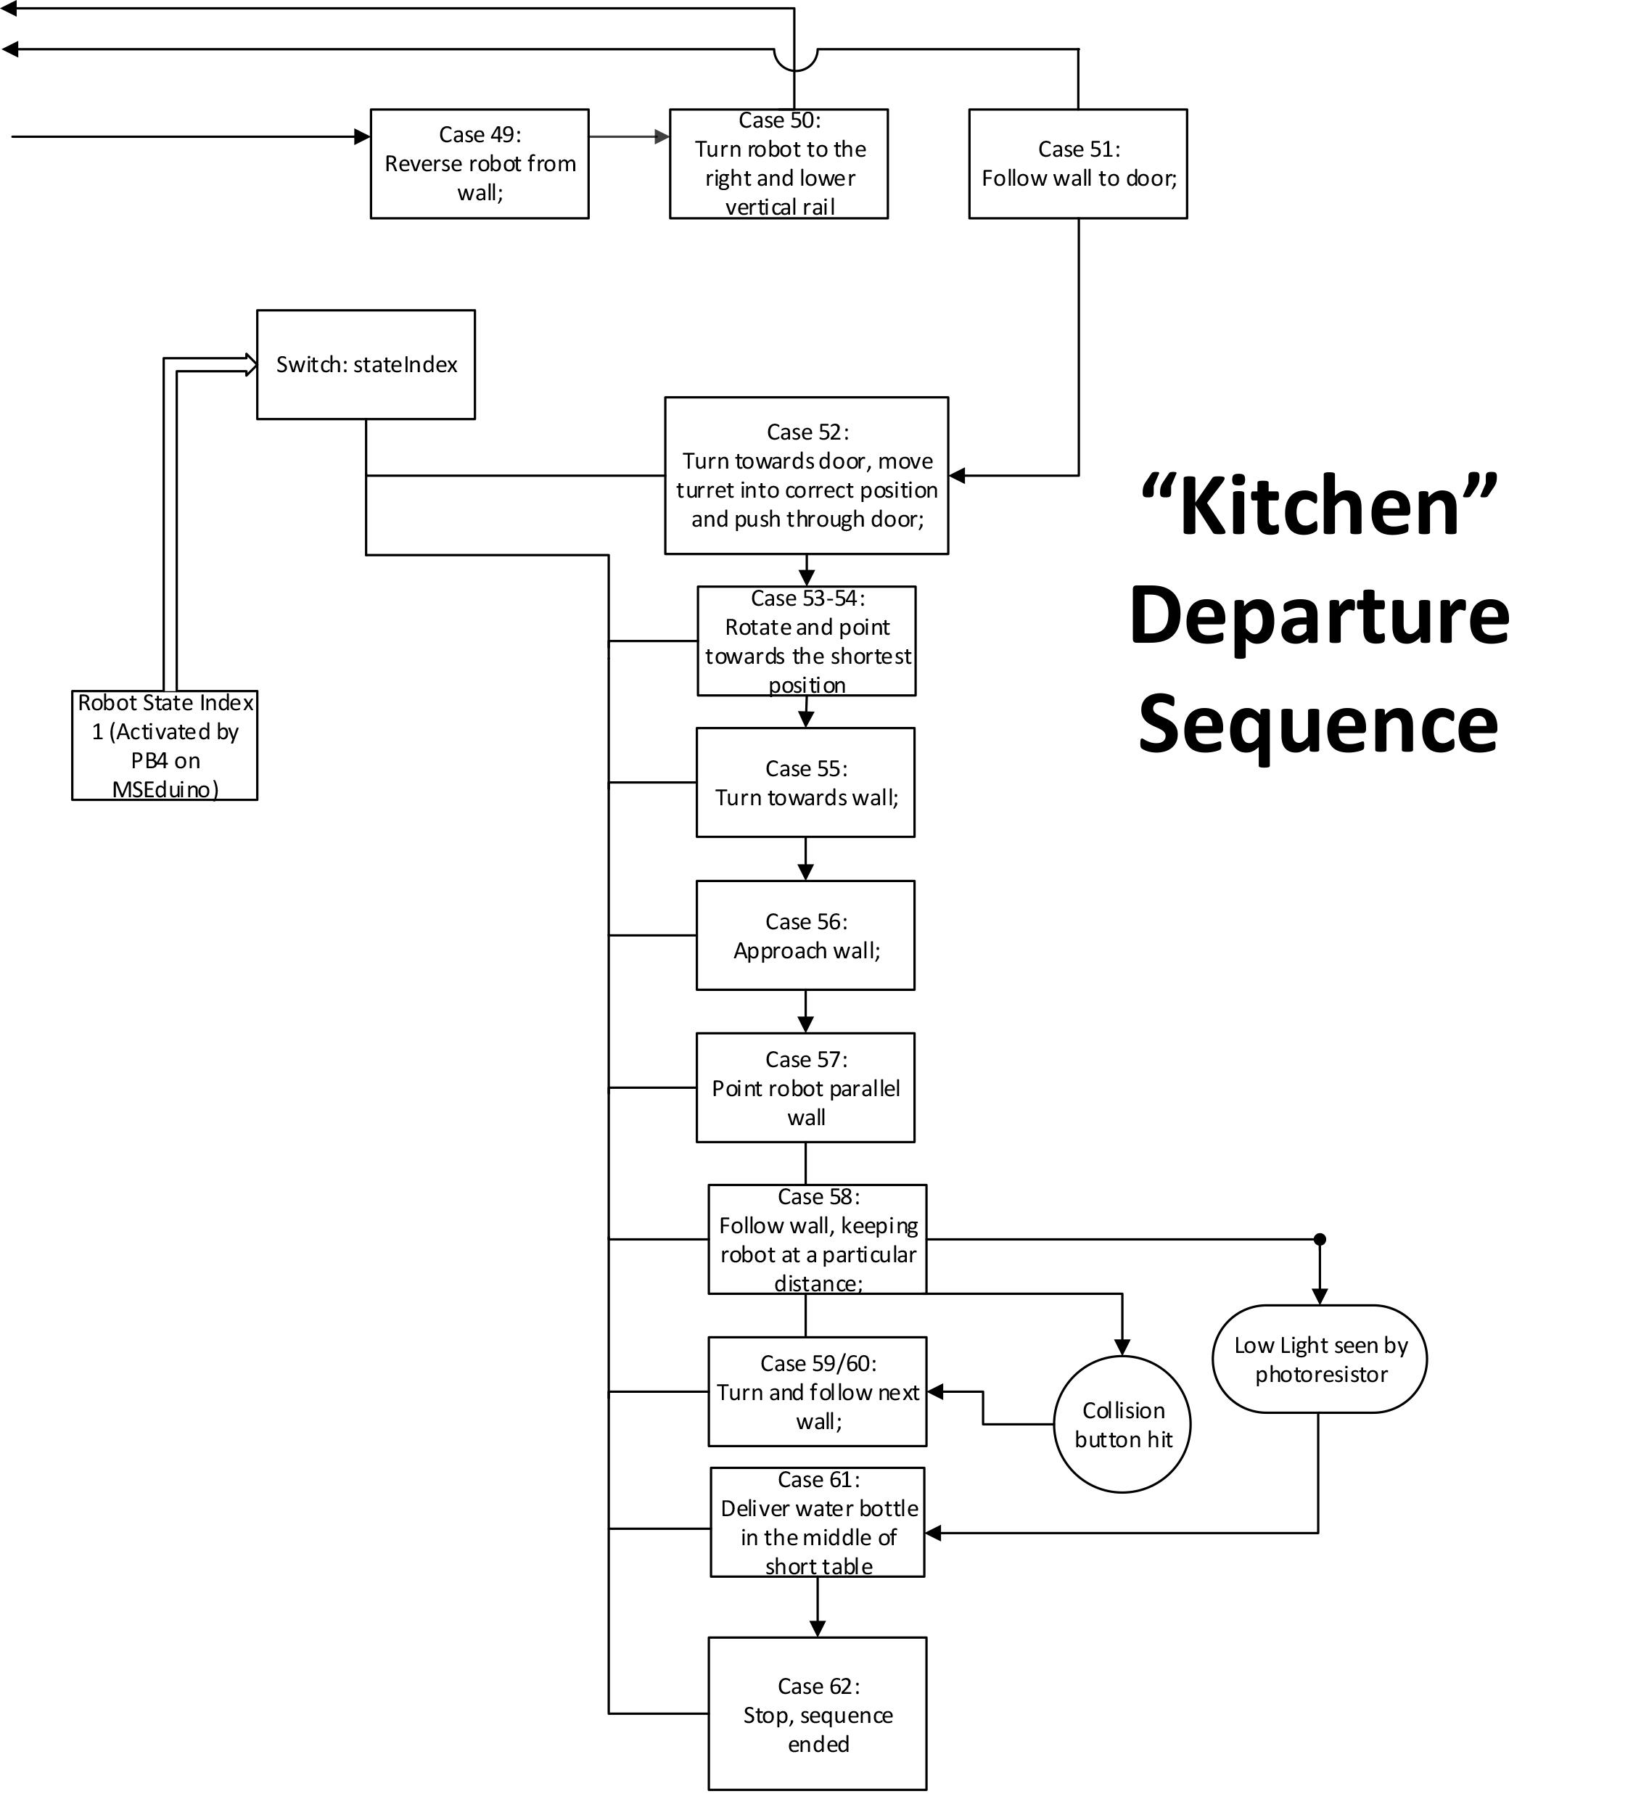

**Appendix IV: Decision Matrices**

Matrix used to determine the best vertical movement system for the robot

|  |  |  |  |  |  |  |
| --- | --- | --- | --- | --- | --- | --- |
|  | Easy To Code | Stable | Strong | Only Vex Components | Easily Mounted To Chassis | Efficient |
| Easy To Code | 1 | 2 | 2 | 1 | 3 | 2 |
| Stable | 0.5 | 1 | 1 | 0.5 | 1 | 2 |
| Strong | 0.5 | 1 | 1 | 0.75 | 1 | 1 |
| Only Vex Components | 1 | 2 | 1.333333333 | 1 | 3 | 0.5 |
| Easily Mounted To Chassis | 0.333333333 | 1 | 1 | 0.333333333 | 1 | 0.5 |
| Efficient | 0.5 | 0.5 | 1 | 2 | 2 | 1 |

|  |  |  |  |  |
| --- | --- | --- | --- | --- |
| Totals | Tooth Rail | Winch System | "BF" Arm | Scissor Lift |
| 11 | 0 | 0 | -1 | -1 |
| 6 | 1 | 0 | 0 | 1 |
| 5.25 | 1 | 0 | 1 | 1 |
| 8.833333333 | 1 | 0 | -1 | 1 |
| 4.166666667 | 1 | 0 | 1 | -1 |
| 7 | 1 | 0 | -1 | 1 |
| Score Summations: |  |  |  |  |
| Easy To Code | 0 | 0 | -11 | -11 |
| Stable | 6 | 0 | 0 | 6 |
| Strong | 5.25 | 0 | 5.25 | 5.25 |
| Doesn't Require Non Vex Components | 8.833333333 | 0 | -8.833333333 | 8.833333333 |
| Easily Mounted To Chassis | 4.166666667 | 0 | 4.166666667 | -4.166666667 |
| Efficient | 7 | 0 | -7 | 7 |
|  |  |  |  |  |
| Totals: | 31.25 | 0 | -17.41666667 | 11.91666667 |

**Matrix used to determine the best design for our final product**

|  |  |  |  |  |  |  |
| --- | --- | --- | --- | --- | --- | --- |
|  | Durable | Stable | Small Footprint | Safe | Easy to Mount Arms | Aesthetically Pleasing |
| Durable | 1 | 1 | 4 | 2 | 3 | 4 |
| Stable | 1 | 1 | 3 | 2 | 2 | 4 |
| Small Footprint | 0.25 | 0.333333 | 1 | 1 | 0.75 | 2 |
| Safe | 0.5 | 0.5 | 1 | 1 | 0.75 | 3 |
| Easy To Mount Arms | 0.333333 | 0.5 | 1.333333333 | 1.3333333 | 1 | 4 |
| Aesthetically Pleasing | 0.25 | 0.25 | 0.5 | 0.3333333 | 0.25 | 1 |

|  |  |  |  |
| --- | --- | --- | --- |
| Totals | Trash Can | Scorpion | Quad Bike |
| 15 | 1 | 0 | 1 |
| 13 | 1 | 0 | 0 |
| 5.333333333 | -1 | 0 | -1 |
| 6.75 | 1 | 0 | -1 |
| 8.5 | 1 | 0 | 0 |
| 2.583333333 | -1 | 0 | -1 |
| Score Summations: |  |  |  |
| Durable | 15 | 0 | 15 |
| Stable | 13 | 0 | 0 |
| Small Footprint | -5.333333333 | 0 | -5.333333333 |
| Safe | 6.75 | 0 | -6.75 |
| Easy To Mount Arms | 8.5 | 0 | 0 |
| Aesthetically Pleasing | -2.583333333 | 0 | -2.583333333 |
|  |  |  |  |
| Totals: | 35.33333333 | 0 | 0.333333333 |

**Matrix used to determine the best method of coding the robot for movement**

|  |  |  |  |  |  |  |
| --- | --- | --- | --- | --- | --- | --- |
|  | Easy To Implement | Not Resource Intensive | Few Sensors Required | Gives Information | Little or no Blocking | Easy To Understand |
| Easy To Implement | 1 | 2 | 1 | 3 | 2 | 4 |
| Not Resource Intensive | 0.5 | 1 | 1 | 2 | 2 | 4 |
| Few Sensors Required | 1 | 1 | 1 | 3 | 3 | 4 |
| Gives Information | 0.333333333 | 0.5 | 0.333333333 | 1 | 2 | 3 |
| Little or no Blocking | 0.5 | 0.5 | 0.333333333 | 0.5 | 1 | 4 |
| Easy To Understand | 0.25 | 0.25 | 0.25 | 0.333333333 | 0.25 | 1 |

|  |  |  |  |
| --- | --- | --- | --- |
| Totals | Clockwise Navigation | Mapping | Duo Ultrasonic Sensors |
| 13 | 1 | -1 | 0 |
| 10.5 | 1 | -1 | 0 |
| 13 | 1 | 1 | 0 |
| 7.166666667 | 0 | 1 | 0 |
| 6.833333333 | -1 | 1 | 0 |
| 2.333333333 | -1 | -1 | 0 |
| Score Summations: |  |  |  |
| Easy To Implement | 13 | -13 | 0 |
| Not Resource Intensive | 10.5 | -10.5 | 0 |
| Few Sensors Required | 13 | 13 | 0 |
| Gives Information | 0 | 7.166666667 | 0 |
| Little or no Blocking | -6.833333333 | 6.833333333 | 0 |
| Easy To Understand | -2.333333333 | -2.333333333 | 0 |
|  |  |  |  |
| Totals: | 27.33333333 | 1.166666667 | 0 |

With the use of your design matrices we were able to determine the best of our generated ideas based on a list of criteria predetermined to be most effective at meeting the objectives assigns to us through this project. It was the results of these design matrices that helped us to determine both the prototype and eventually the final design of our product.

**Appendix V: Design Reviews**

Design review #1

Progress:

There have been many developments of this project in order to create a mechatronic device to assist with the delivery and recycling of water bottles and newspapers within a home. A description of necessary components of the robot and the programing were determined at the start followed by a set of base designs of the robot that seemed reasonable given the requirements outlined prior. Each group member was able to design a robot or parts of a robot and a conclusion on the basic design was determined. The base design included a standard rectangle base with four wheels with a rail neck mounted to the center to allow for easy height adjustment of the arm. The arm or claw is currently going to remain the same as the claw used in the labs earlier this semester. The simple base design has been built to accommodate 4 wheels and the mounting of the neck and arm that will be attached after each component is finished. The neck of the robot is almost done. The neck design is a basic rail design that uses a motor to change the height of where the arm will be on the track. The height of the arm can be adjusted using this design and start from 21cm above the ground and move to a maximum of approximately 58cm. The base and neck of the robot have been designed using CAD modeling and used for computer modeling during construction.

Plan:

For the next month the main tasks that need to be accomplished are: finishing the construction of the robot and attaching the sensors, programming the sensors and motors of the robot, the final CAD modeling of each component, the Design Report and the final prototype of the design for the showcase. Currently, we are almost finished with the construction of the robot except for the attachment of the sensors. In the next couple weeks each group member will either help finish the construction, start programming the sensor or begin the design report. Along the way, there will be CAD modeling for each stage as well as notes taken in our design notebooks. There are a few ideas for the design report that have been discussed including; how the discussion will include some of the obstacles the have been taken into account along the way as well as the adjustments that have already been made and the adjustments that will be made to the robot and the program when the testing begins. We plan on providing testing data from each phase going into the final weeks.

Design review #2

Progress:

Several revisions to the initial mechanical design of the robot, as well as the sensor set up and coding methodology have been made in order to improve upon the original design.

The mechanical design has been revised in order to make it more durable when dealing with the bending moments and torsional forces that result from rotating the long rail, and the added weight from the arm and rail mounts. The chassis had an extra angle channel added to reinforce the wheels from both sides to deal with the bending in the wheel shafts. A roller pin support has been added to the horizontal rail dolly because the plastic slider piece which was made to hold it up by vex does not remain rigid once the arm has become fully extended. In addition, to deal with the difference in table heights, as well as the depth of the table, two vertical rails measuring 24 inches long, and one horizontal rail measuring 30 inches long have been machined. The basket design has been scrapped and replaced by an intake design, which is lighter and is better at retrieving paper. The group plans on purchasing some wire sleeves to protect the cables from rotating parts and to better help cable management. In addition a 7.2 volt 6 cell NIMH battery was purchased from taxes in order to allow for testing and development outside of the battery and also to provide a reliable power platform for both boards. To deal with all the mechanical changes in the design, several sensors have had their positions adjusted to better compliment the mechanical design.

The sensors used by the robot include both ultrasonic sensors, as well as both light sensors; two line tracking modules, and a collision button. One ultrasonic sensor is positioned on the right side of the robot to help with navigation. The other ultrasonic sensor is located above the gripper in order to help with the detection of the water bottle. The two line tracking modules are used for paper detection. One of the line trackers is used in order to detect the paper on the table and is connected to the master board. The slave board has one line tracker module that signals the intake motor to stop moving when the paper has been retrieved. The light sensors are mounted at the same heights as the LEDs in the room at a fixed position in order to detect the LEDs without any change in height required. A collision button helps the robot determine when it has reached the end of a wall segment. The sensor input is used to actuate the motors and servos on the master and slave boards.

The master board and slave board both have motors, which they actuate. The master board controls all arm and rail motors, the turntable motor, the gripper motor, and the left and right motion motors. The slave board controls the intake motor.

Coding has been adapted to function through a switch statement, which can be iterated through a decision tree. In order to calibrate the turret, a mechanical stop is put in place, which can then be used to determine how many encoder counts the turret is away from the mechanical stop. This is then translated to degrees with respect to being perpendicular to the right face of the robot. After turret calibration the robot searches for the nearest point in the room through rotating, it then adjusts its distance to that point to what it should be and begins tracking the wall using similar logic to the line tracking algorithms that were used in previous labs. The code that is left to be determined is the grabbing sequence. The turret calibration, wall detection, and wall tracking algorithms have all been tested and are working. The code that is left to be finalized is grabbing sequences and delivery sequences. In order to manage the versions of code made by the group, GitHub is being used to keep track of versions.

**References**

Vex Components. <http://www.vexrobotics.com/>

Thrun, Sebastian. (2002, February). Robotic Mapping: A Survey.

<http://robots.stanford.edu/papers/thrun.mapping-tr.pdf>

J. Borenstein, H.R. Everett, and L. Feng. “Where Am I?” Sensors and Methods for Mobile Robot Positioning. 1996. <http://www-personal.umich.edu/~johannb/Papers/pos96rep.pdf>

Vex. Creating Vex Compatible Parts Using 3D Printing Technology. <http://www.vexrobotics.com/vexiq/documents-downloads/3d-printing/>

Lomar Machine & Tool. Gear Tooth Size - General Information. Accessed Mar 15, 2015. <http://www.rack-and-pinion.com/pdf_files/Rack%20&%20Pinion%20Gear%20Tooth%20Chart.pdf>

Bonn. 09/24/2014. Press Release - DHL Parcelcopter launches initial operation for research purposes.

<http://www.dhl.com/en/press/releases/releases_2014/group/dhl_parcelcopter_launches_initial_operations_for_research_purposes.html>

Vassilis Vaveropoulos. *Robot Localization and Map Construction Using Sonar Data.* Retrieved March 29, 2015 from http://rossum.sourceforge.net/papers/Localization/PosPosterv4.pdf

Feil-Seifer, David and J Maatrie, Maja. *Defining Socially Assistive Robotics.* July 1, 2005. Retrieved March 29, 2015 from http://robotics.usc.edu/publications/media/uploads/pubs/442.pdf